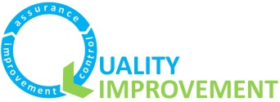
Identifying a quality issue and starting a QI project
To be completed by proposed Project Lead

- What’s the issue/problem?

- How do we know that we have a problem with it at the moment?

- What is our quantitative data telling us?

- What are we hearing from our stakeholders, staff, service users and families?

- Please review section B overleaf. How complicated/complex do you think solving this problem will be on a scale of 1 (being the lowest) to 10 (being the highest)? Please describe briefly (1-2 sentences) why have you given the score you have?

- Who would need to be on a project team for this project and who has committed to being involved so far?

- As the project lead, what QI training have you had?

- What are your ideas around involving service users, carers or directorate customers in the project?

As the Project Lead, please review the role and responsibilities overleaf and confirm your commitment to undertaking this role, including keeping your sponsor updated at least monthly on your project’s progress, so they can support you. Please see overleaf for a summary of the QI Sponsor and QI coach roles in your project.
- Roles in QI

B. Signs your project is right for QI or whether another approach may be needed

Not all problems/issues need QI to address them.
QI is best suited and most helpful for the more complicated/ complex problems. To the right are two lists of signs that your problem is more or less complicated – to help you identify whether it will be right for a QI approach of if another approach is needed.
Your QI Forum will be interested in your views and thinking on this to talk through further with you.
