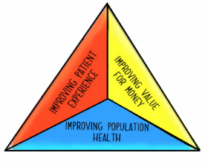
Step One - Identifying a Population
Where to start – segmenting a population
ELFT serves a population of over 1.4m which will rise to just under 1.7 m by 2021. When we think about improving population health, this leads us to ask where should we start?
One way in which we can answer this is by targeting specific groups with similar characteristics within your total population – known as segmentation.

Total Population

Ways to segment a population

There are many ways in which to segment a population, but some ways to think about this include:
Geography – one borough, one CMHT, one GP practice
Disease burden/diagnosis –people with grade two pressure ulcers, people with personality disorder
Demography – Age, Gender, Ethnicity
Lifecourse – Children and Young People, Working age adults, complex care
It’s likely that your choice of segment might include a combination of the above

Population Segment

Things to consider when choosing a population
You might have a number of potential population segments in consideration. Below are some key things to consider when picking where to start:
- Is there an opportunity to improve all 3 aspects of the triple aim – population health outcomes, quality of care provided, and value for money?
- Is there a segment of the population that is failing to thrive, where there might be some inequity apparent?
- Is there an urgency to do something differently / redesign the system for this population segment?
- Do we have a really good idea who is in of this population? (Can we count them?)
- Do we have access to data that we can track regularly on outcomes, quality of care and value?

- Are there other organisations/agencies who share responsibility for this population that are willing to partner with us in this work?

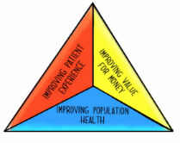
Insert population below | In what way is this population not thriving at present? | Is there an opportunity to impact on all three aspects of the triple aim? | Is there urgency to do things differently? | Do we have a good idea who is in the population? Who are they? Can we count them? | Do we have data available that we can track regularly? | Which organisations/agencies share responsibility for this population? How willing are they to partner with us?

