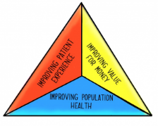
Engagement Event for Developing Change Ideas with Partners

Working to improve the health outcomes, experience and value for a specific population will require you to work outside of ELFT with local partners in the wider system. Consequently, you will sometimes need to work with partners to design new ways of supporting the population you are working with. To help you do this we’ve put together a guide of how to run a workshop with partners

Step One – Plan the event
- Using your driver diagram, identify the area of work you feel will have the most impact on helping work towards meeting your aim
- Identify which are the most important 2-3 partners you need to work with to make this happen and invite them to a session

Step Two – Develop a case study
- Use the learning from your three-part data reviews and develop a case study of a particular person living in the population.
- This will help you ground any conversations you have with partners in the issues within the population and actively work to design interventions to meet those.

Step three – Hold the event
In order to get the most out of the session we would encourage you to work towards developing a plan of what you are going to do by the end of the session.

- Set the scene of work you’ve done so far and why the population is important
- In small groups use the case study you’ve prepared and work through the following questions.
  - What does this tell us about what is not working in the system?
  - What is the most important thing we are already doing to tackle this?
  - What is there something we could do together to try and improve this?
  - What do we need to do in the next month to make this happen?
- Decide on how to take the next steps forward

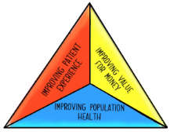

What does this tell us about what isn’t working in the system?
What is the most important thing we are already doing to tackle these problems?
What is something we could work on together to try and improve this?
What do we need to do next to make this happen?

