Task 1: Diary Management
Please find a diary snippet below for Jaz, Tim, and Ericka from the QI Team.
Below are three meetings that need to be booked within these days – your task is to find an option for each meeting to be held and to request a relevant room booked for each. When booking a room, you need to contact reception via email to confirm bookings and availability.
Room details are in the table below:
Training Room | 30 people | Screen and projector
Meeting Room 1 | 6 people | Conference phone
Meeting Room 2 | 6 people | Screen, projector, spider phone
Meeting Room 3 | 4 people | Conference phone
Meeting Room 4 | 20 people | Conference phone

Meeting 1: Book a meeting for Jaz and Tim for an urgent Webex that colleagues from Luton IAPT will join depending on their availability – expecting at least 4-6 people to join online for 1 hour.
Meeting 2: Find time for Ericka to meet with the Chief Exec to discuss communications, needs to be on Thursday 11 or Friday 12 January – 1 hour.
Meeting 3: Jaz and Tim are required for an hour to be part of a service user and carer presentation on their involvement within QI, 20 attendees are expected.
Please use the space below to write out your solutions. Save this document with your name and attach it to the email you will send to elft.qi@nhs.net after the completion of task 2 below.

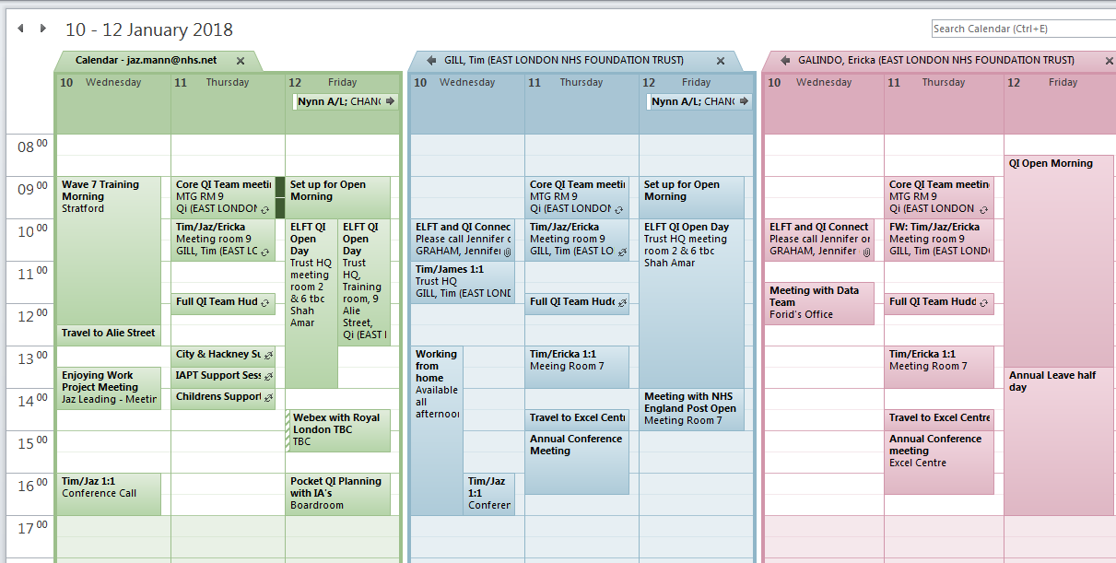
Task 2: Venues
Here you will find notes on a few venues that we have looked into recently, please collate these notes into a document that can be used as a quick reference in future with space to add more venues as and when we find them. Feel free to use any document type you think will help. Once completed please save your document, using your name in the file name and email it to elft.qi@nhs.net

